Proof of Testing: USB e-Tour

# Android application Black box Testing:

The following test plan is for a member of the team who is unaware of the internal structure / design / implementation of the application being testing. The system can be tested by any member not part of the back-end team.

|  |  |  |
| --- | --- | --- |
| **Test No.** | **Test Description** | **Expected Result** |
| 1 | Download Android application | Application downloads successfully |
| 2 | Run the application | Application runs/open successfully and you can see the home screen |
| 3 | move around the building using the app to navigate - stairs | give good and accurate directions to the  destination |
| 4 | move around the building using the app to navigate - lifts | give good and accurate directions to the  destination |
| 5 | take a tour of the building using the app | the tour runs successfully and produce  information accurately |

## Test 1: Downloading the application

The app downloads successfully and displays properly on the device there were no problems / complications in this test.

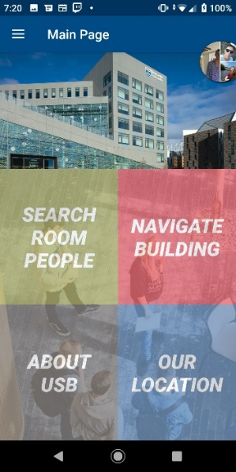

## Test 2: Run the application

The application runs successfully and opens of the main menu.

## Test 3: move around the building using the app to navigate – stairs

### Moving around using stairs test 1: 1.006 lecture theatre to 6.013

Test successful, the app finds the shortest path correctly and displays the path as shown in the screen shots, it also starts on the starting floor correctly.

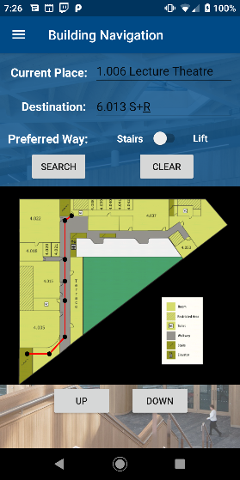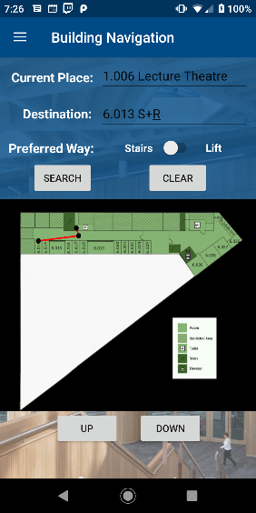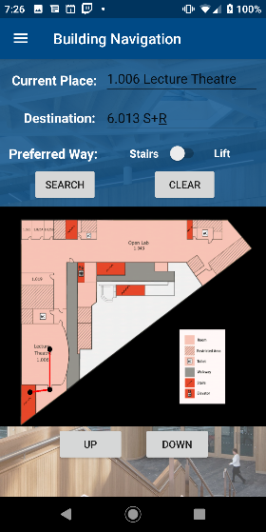

### Moving around using stairs test 2: 2.004 Group Study Area to 3.034 Tutor office

Initially was unsuccessful as a stair’s node was connected to an incorrect node and this was rectified.

After the change the test was successful with no problems.

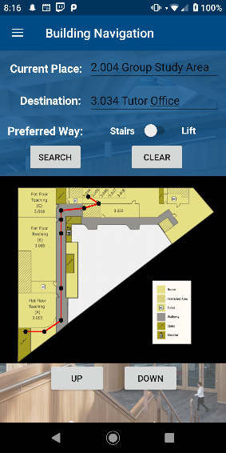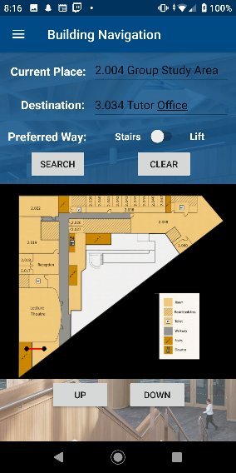

Notes:

Only issue that may occur is that on floors where the user will only use the stairs there is no indication of continuing to use those stairs.

Nodes could have a little better placement as sometimes the path goes back on itself a bit.

## Test 4: move around the building using the app to navigate – lifts

### Moving around using lifts test 1: 1.006 lecture theatre to 6.013

Test successful, the app finds the shortest path correctly and displays the path as shown in the screen shots, it also starts on the starting floor correctly.

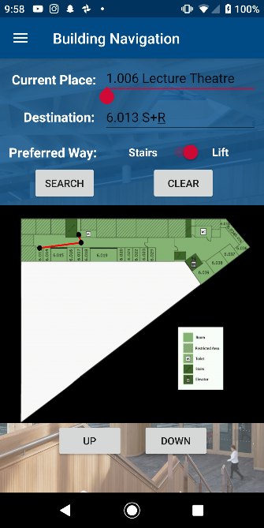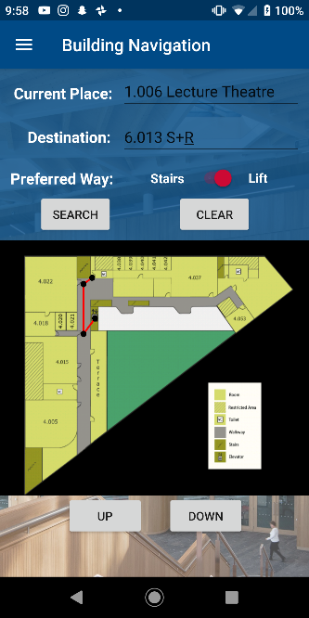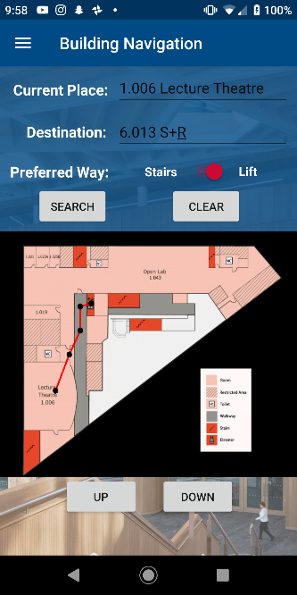

### Moving around using lifts test 2: 2.004 Group Study Area to 3.034 Tutor office

Test successful, the app finds the shortest path correctly and displays the path as shown in the screen shots, it also starts on the starting floor correctly.

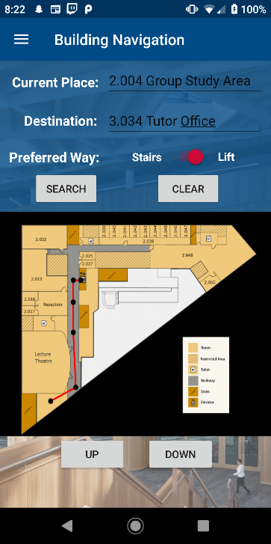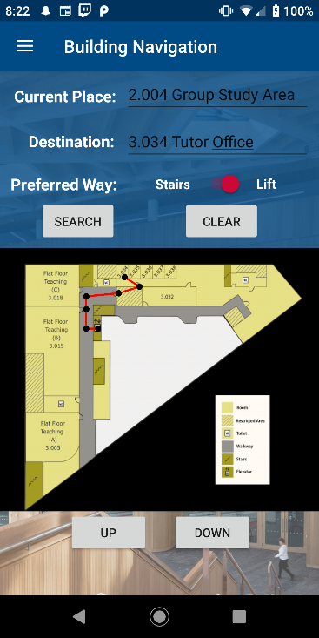

## Test 5: take a tour of the building using the app

This explicit feature of a tour does not exist on the app, however it is able to take the user to any room and has information about said rooms and can be found from the list of rooms, allowing the user to get all the same info about the rooms and then if they desire make their way to the room using the navigation.

Conclusion: This test is not fully successful as an explicit ‘tour’ feature does not exist however the user can find all the relevant information about the rooms on the room search page which would aid in giving the user a tour. The info page also has a “take me there” button allowing the user to be taken to the desired room.

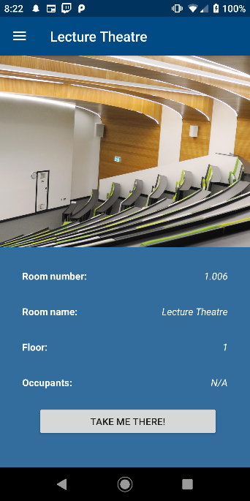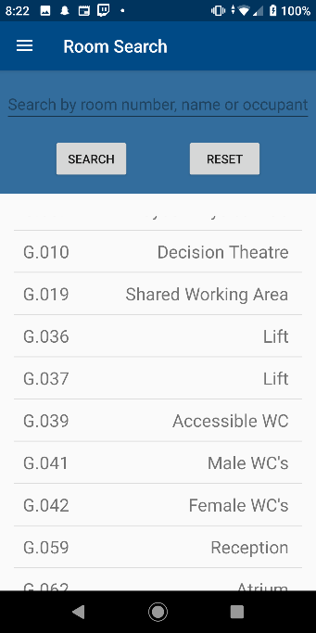

## Additional floor tests: routes across each floor to see if they work and node placement checks.

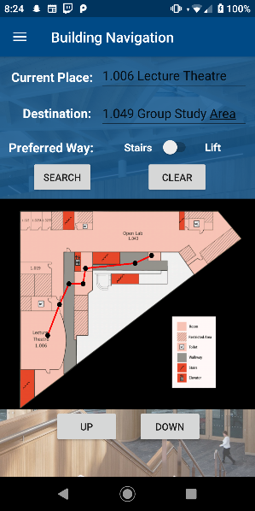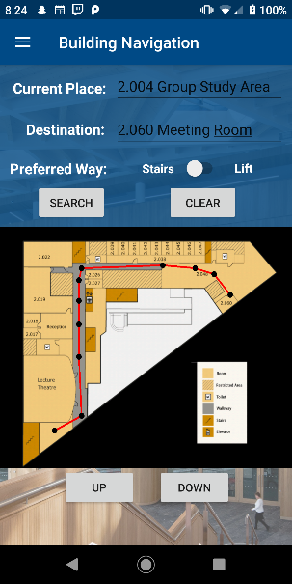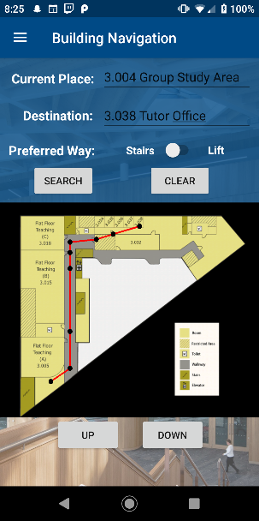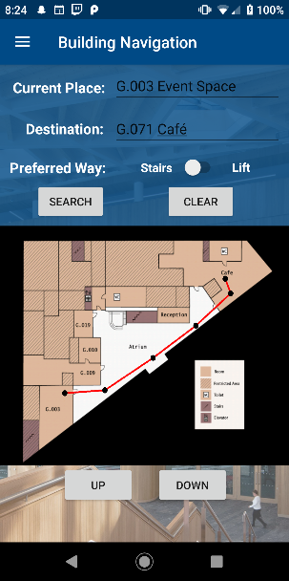The test went well for all floors except floor 6 where an issue was found, two nodes in the database on floor 6 were switched, after fixing the problem there was no issues and the app worked fully as intended.

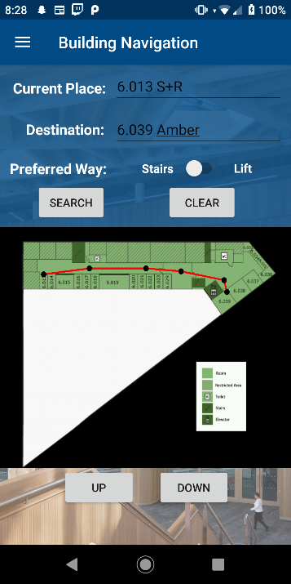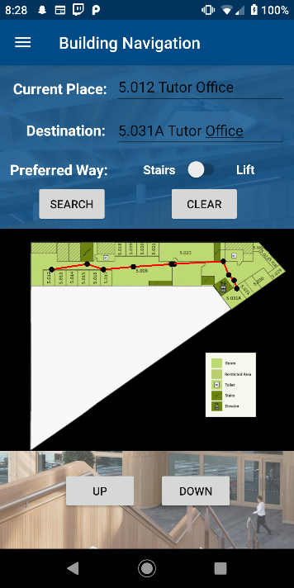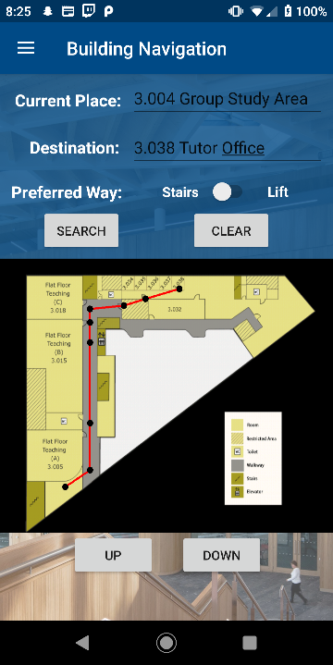

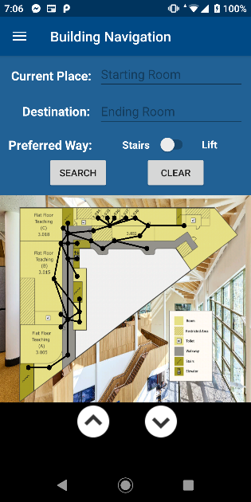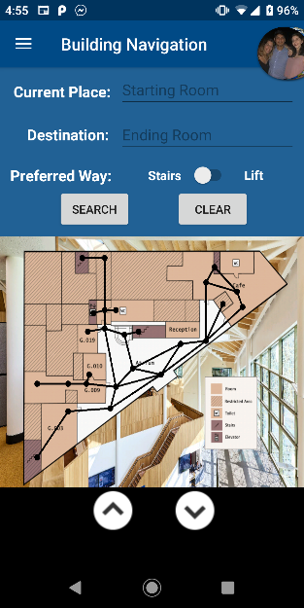Showing all the nodes on each floor, there was one node out of place found on floor 3. After modifying the database ,this error was rectified.

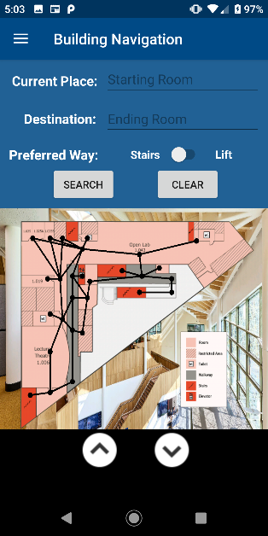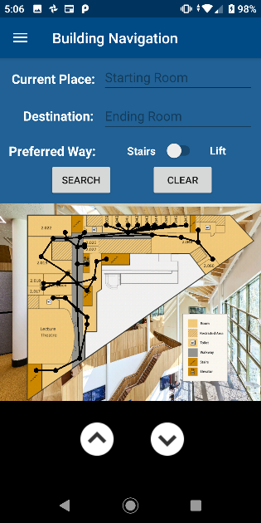

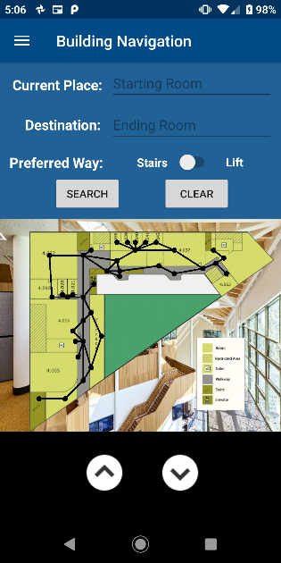

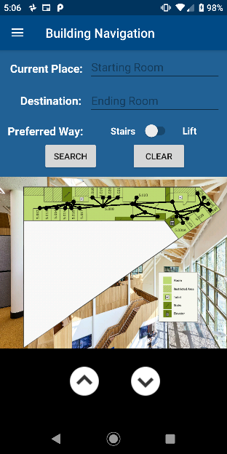

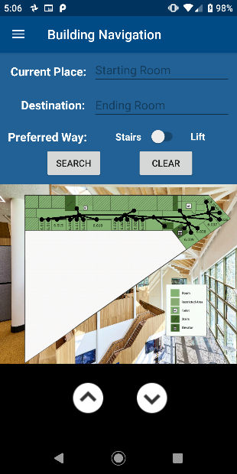

# Android application White box Testing:

A member, or members of the back-end team will use the following testing plan to test the application in detail.

|  |  |  |
| --- | --- | --- |
| **Test No.** | **Test Description** | **Expected Result** |
| 1 | Stress test the app by finding difficult  and long routes to test the app can  make these routes work | The app performs normally and nothing  happens |
| 2 | Unit testing on the database Connection | The app connects normally to the database  and data could be read |
| 3 | Unit testing on the data retrieved from database | Data are retrieved and displayed as  expected |
| 4 | Unit testing on the path finding algorithm | Optimal path to destination |
| 5 | Unit testing on map elements such as nodes, graphs, floors, etc. | Objects work as planned |

## Test 1: Stress test the app by finding difficult and long routes to test the app can make these routes work

### Stress test 1: 1.006 lecture theatre to 6.036 by stairs

Test was successful and found the most efficient route.

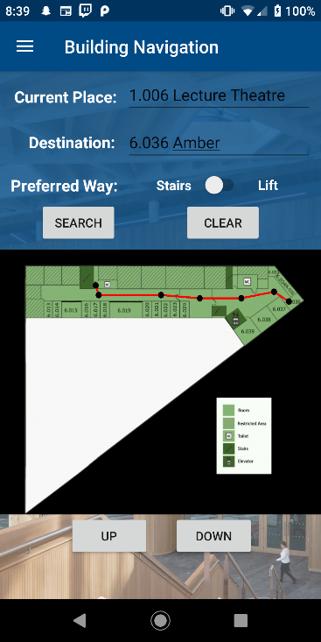

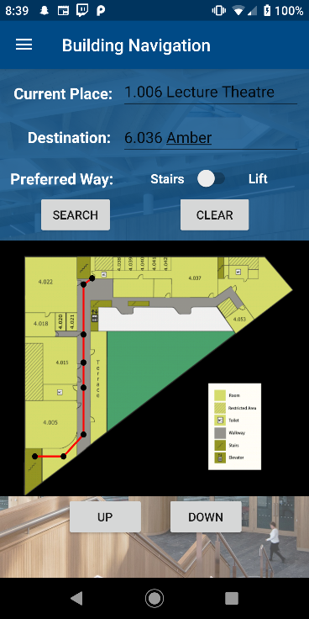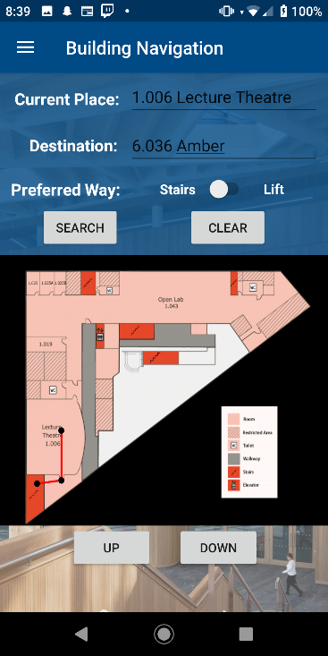

### Stress test 2: G.063 entrance to 6.036 by stairs

Test was successful, found the fastest path to its destination.

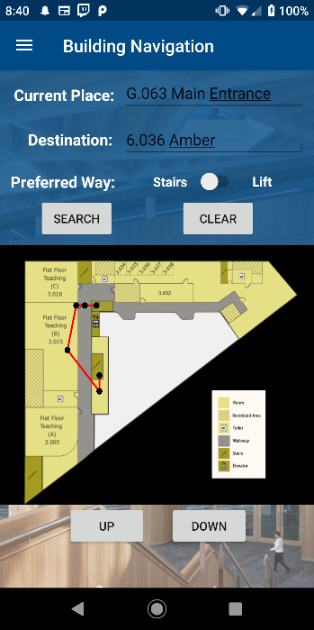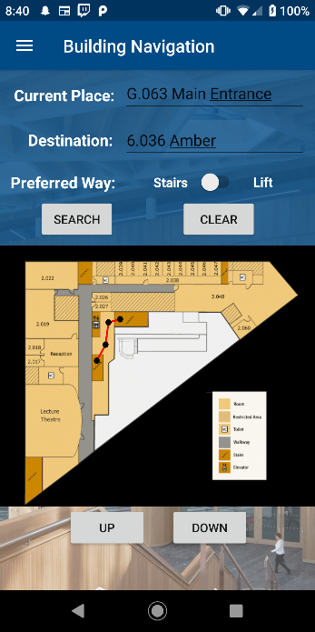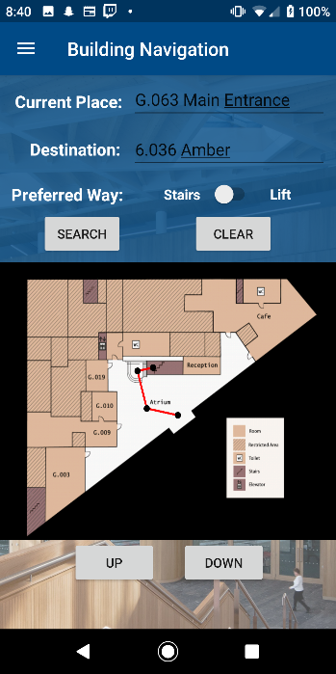

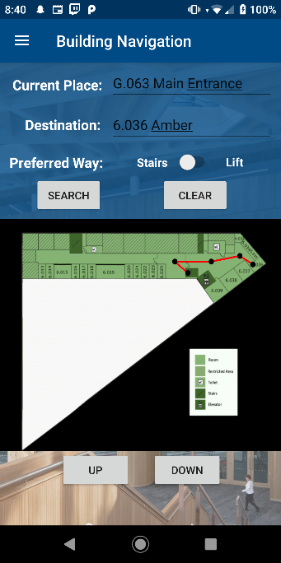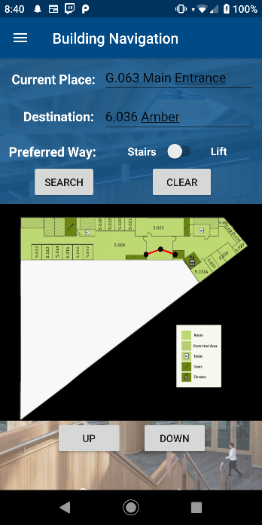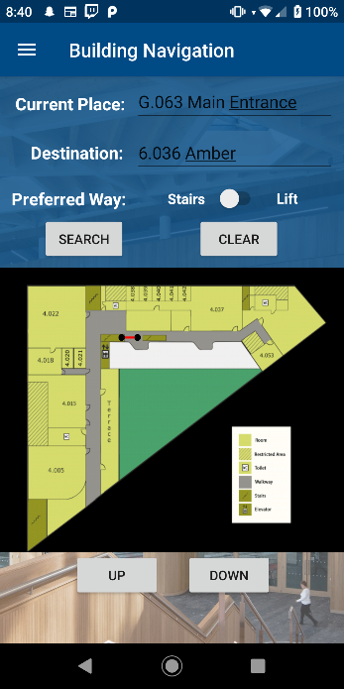

## Test 2: Unit testing on the database Connection

The connection to the SQlite database has been tested to ensure that we are able to pull information from the database into the application. The base of this test attempted to retrieve information regarding staff and rooms from the database; it has since been deleted and has been transformed into the RoomSearch feature to filter through the long list of rooms.

## Test 3: Unit testing on the data retrieved from database

The data pulled from the database has been tested for accuracy in the AFactoryShould test class. In this class, the number of objects pulled from the database is tested for correctness unless if they are edges or transit nodes, in which case we have just tested that the edges and nodes are being generated.

## Test 4: Unit testing on the path finding algorithm

The algorithm itself has been tested by setting up a mock building (no visualisation) in the DijkstraAlgorithmShould test class. In here, tests are performed on the algorithms ability to return the shortest path on the same floor, on different floors, going up, going down, taking either lifts or stairs.

## Test 5: Unit testing on map elements such as nodes, graphs, floors, etc.

This has been demonstrated in previous unit tests included in the app. Tests have been performed on the following map objects such as:

* Building
* Floor
* Room
* Graph
* ElevationNode
* RoomNode
* TransitNode

WEBSITE

# Website White box Testing:

|  |  |  |
| --- | --- | --- |
| **Test No.** | **Test Description** | **Expected Result** |
| 1 | Open on multiple browsers | Runs fine and nothing is broken |
| 2 | Use all the navigation and features of  the website | Runs fine and nothing is broken |
| 3 | Stress test the javascript and make  sure all the functions run as expected | Runs fine and nothing is broken |
| 4 | Resizing the browser size | Website is displayed correctly |
| 5 | Open on different devices | Runs fine and nothing is broken |
| 6 | Load test the website to make sure it  can handle many simultaneous user  requests | Runs fine and nothing is broken |
| 7 | Testing all the links | Correctly directed to the link |

## Test 1: Opens on multiple browsers

The website successfully opens in multiple browsers such as chrome, Internet Explorer and Microsoft edge.

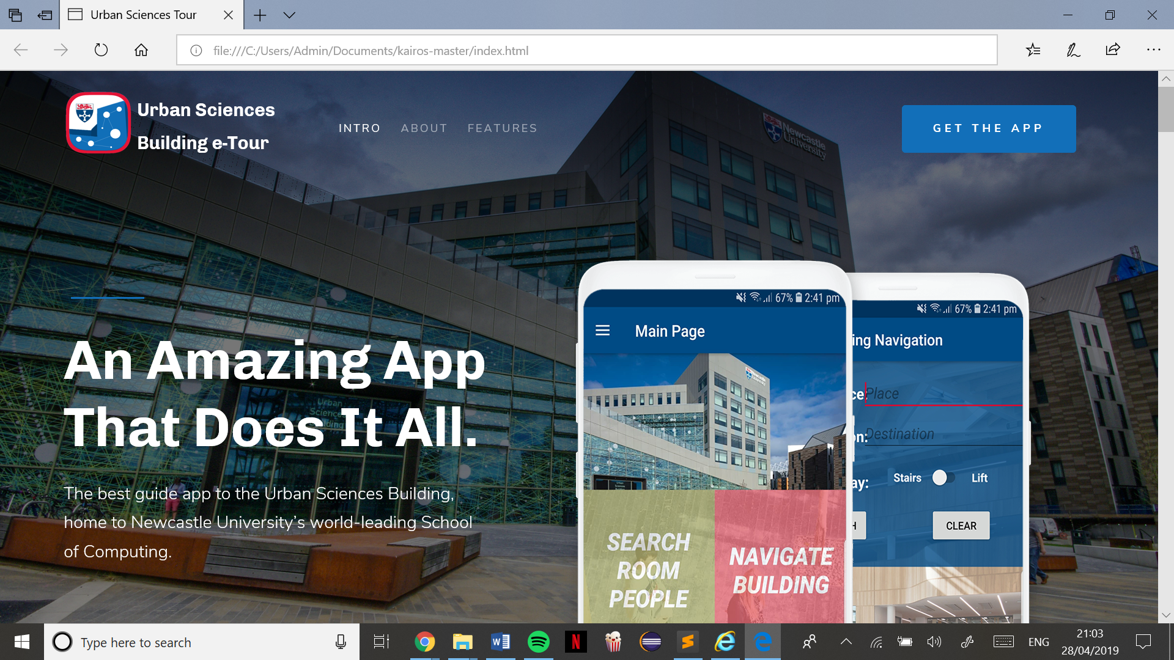 Microsoft Edge

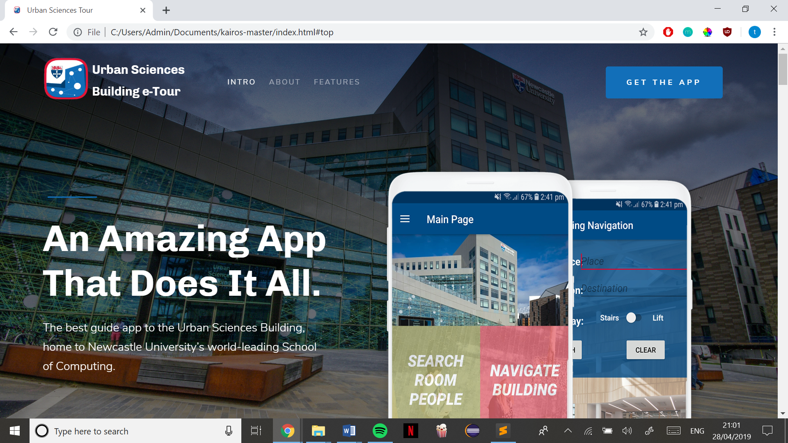 Chrome

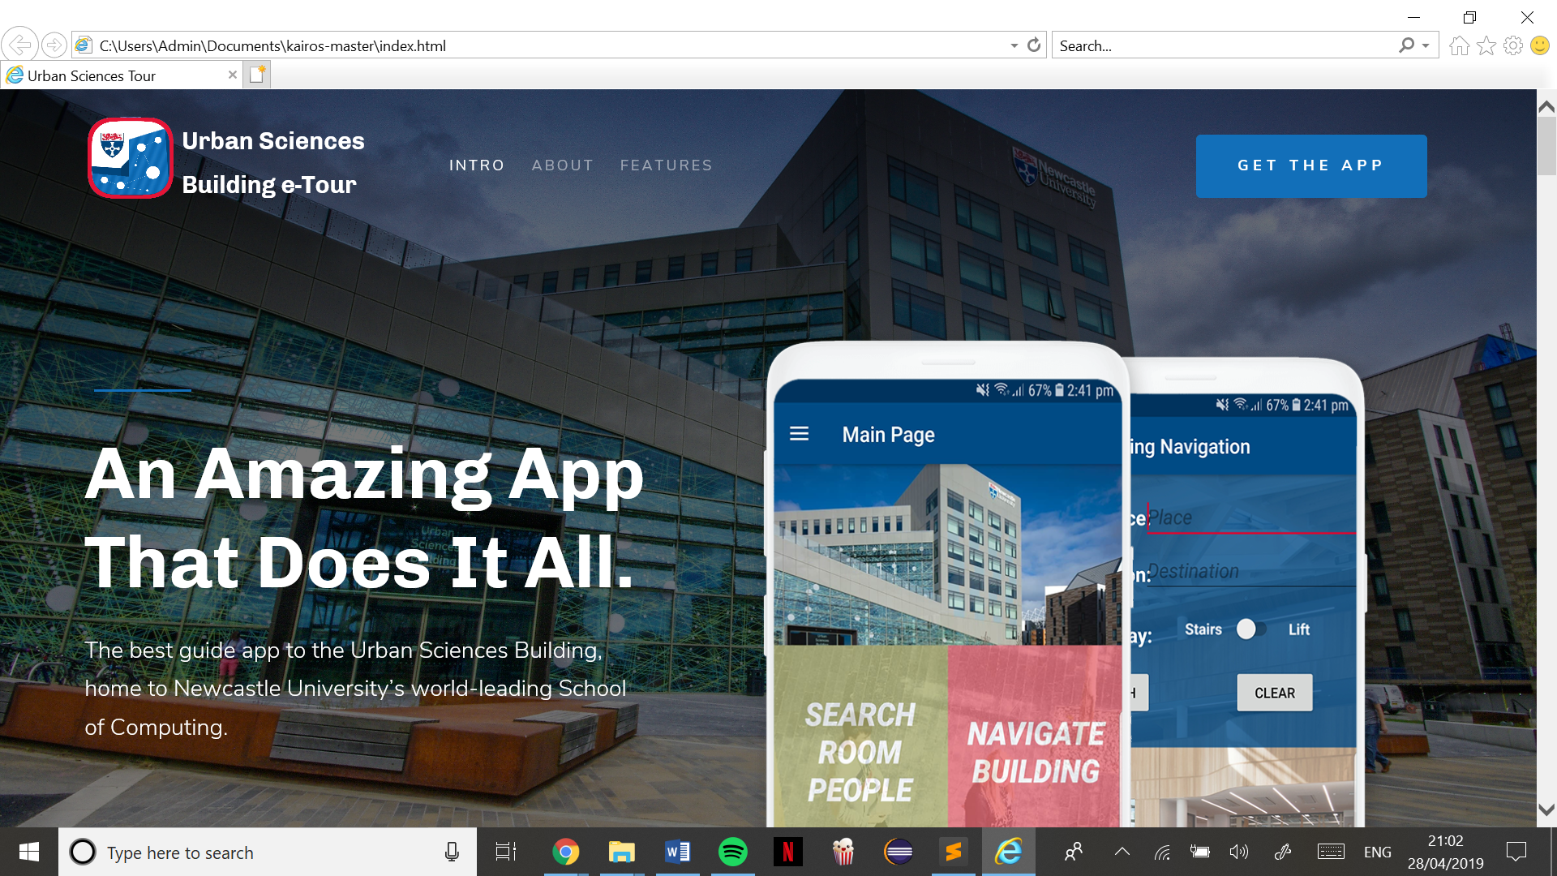 Internet Explorer

## Test 2: Use all the navigation and features of the website

Clicking the links in the navigation bar jumps to the right part of the website and clicking ‘get the app’ takes me to the download section of the page, and clicking the logo ‘urban sciences’ takes me back to the homepage as expected.

Clicking the return to top arrow returns me to the top of the page(homepage) no matter which part of the website I am on.

Clicking the walk-through video pops up the correct tour video from YouTube.

The email subscription box correctly displays a ‘we have sent a confirmation email’ once an email is submitted

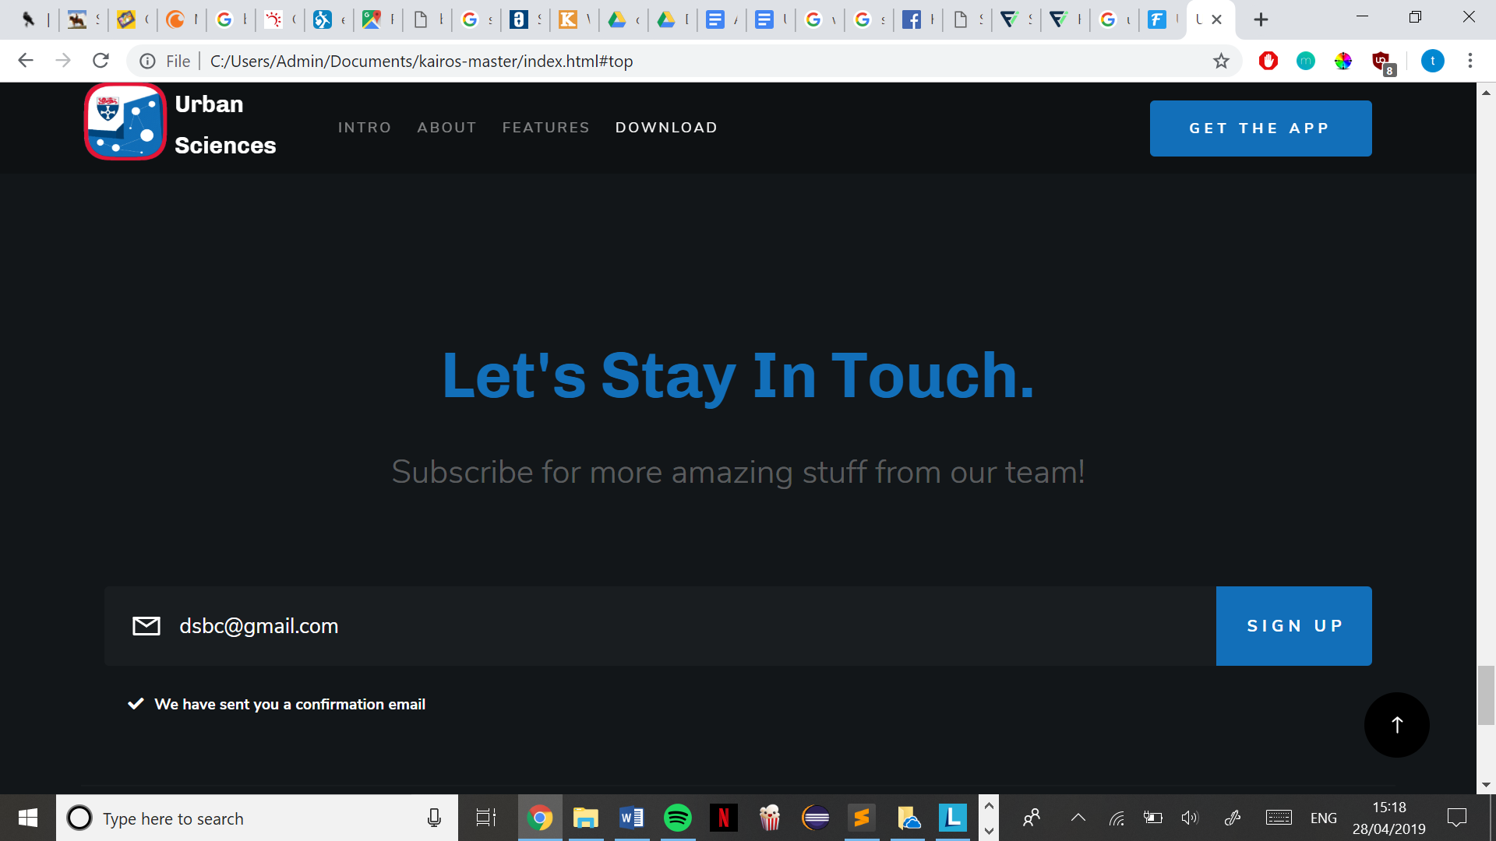

## Test 3: Stress test the Javascript and make sure all functions run as expected

I clicked each featured several times in hopes of breaking it, but it performed its task correctly. For example, I scrolled all the way down, and kept clicking the ‘back to top arrow’ it buffered a bit each time I clicked as it slowed down moving up the page but no number of clicks effected its purpose. All Javascript ran smoothly and without a problem.

## Test 4: Resizing browser

Website runs successfully when resized, displays correctly on any resized size.

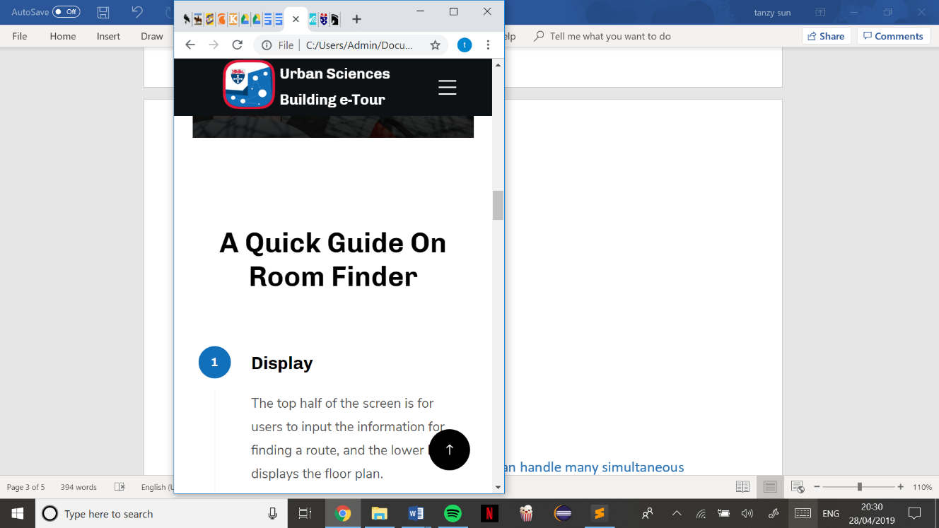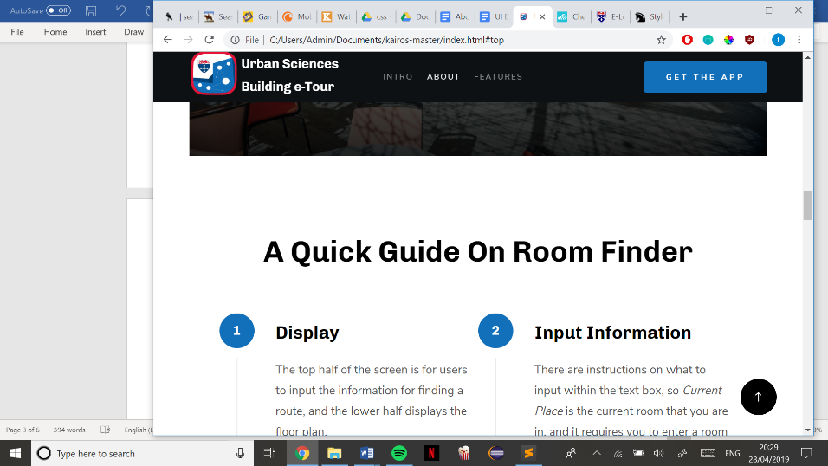

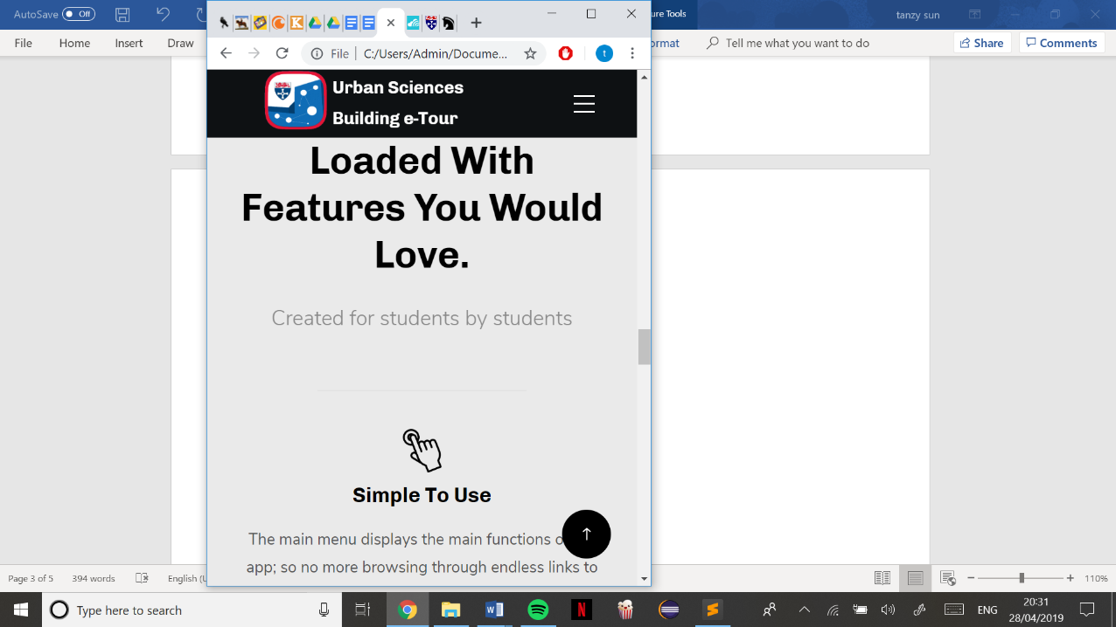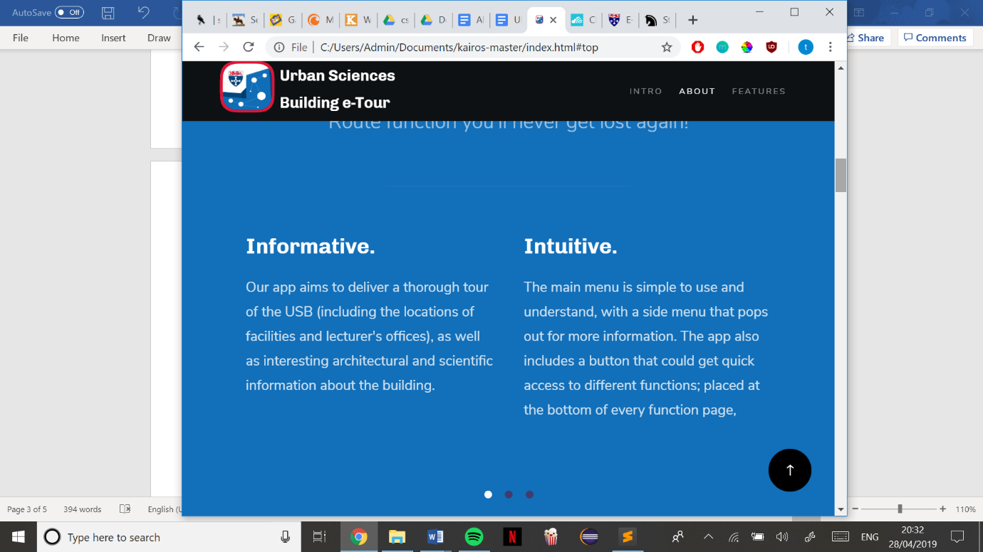

## Test 5: Open on different devices

Website successfully opens and loads on a mobile device.

## Test 6: Load test the website to make sure it can handle many simultaneous user requests

To test this, I had many tabs of the website open in Chrome, and all functions performed smoothly as usual. Several members of the team also had the website open on their own devices and tested each feature, but the website remained unaffected and performed smoothly as usual

## Test 7: Testing all links

There aren’t any external links apart from the YouTube video, which loads and displays correctly, all internal links such as from the navigation bar works correctly.

# Website Black BOX TESTING

|  |  |  |
| --- | --- | --- |
| **Test No.** | **Test Description** | **Expected Result** |
| 1 | HTML code meets the markup  validation | Passes test |
| 2 | CSS code meets the markup validation | Passes test |

## Test 1: HTML code meets mark-up validation

Website passed HTML checks successfully, there’s no errors or warnings.

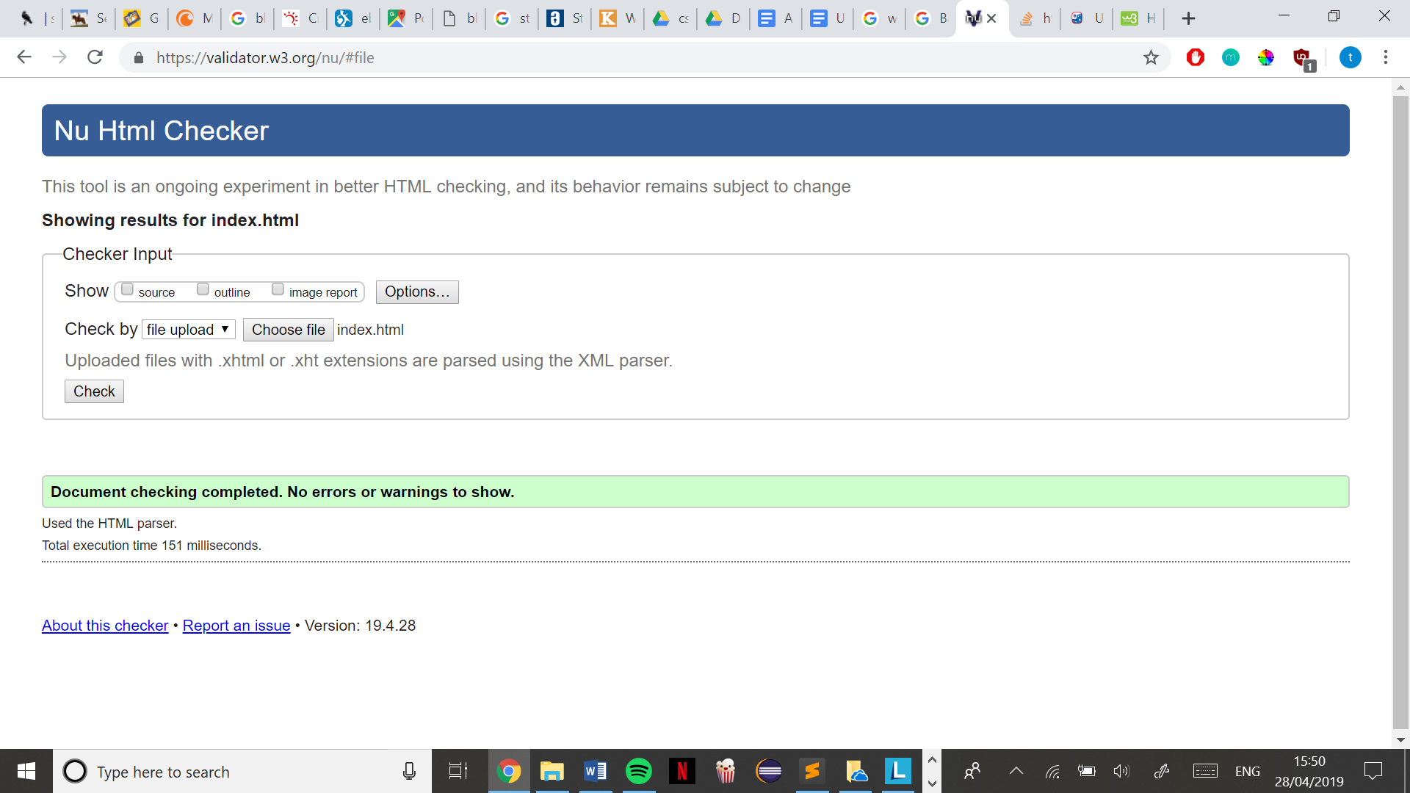

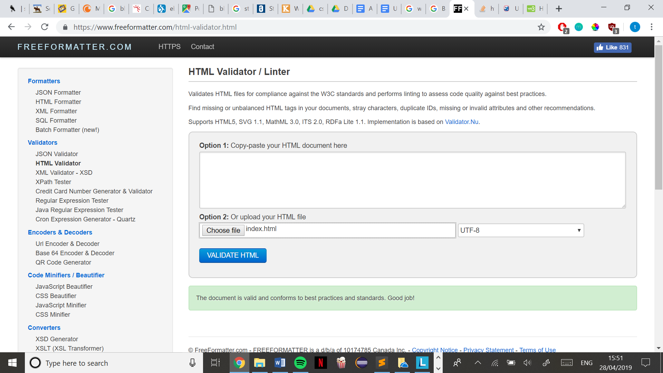

## Test 2: CSS code meets mark-up validation

Base.css successfully passed, no errors found.

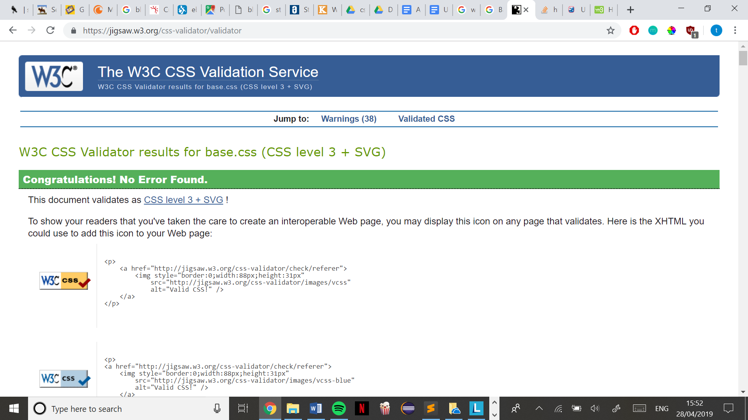

Main.css successfully passed, no errors found.

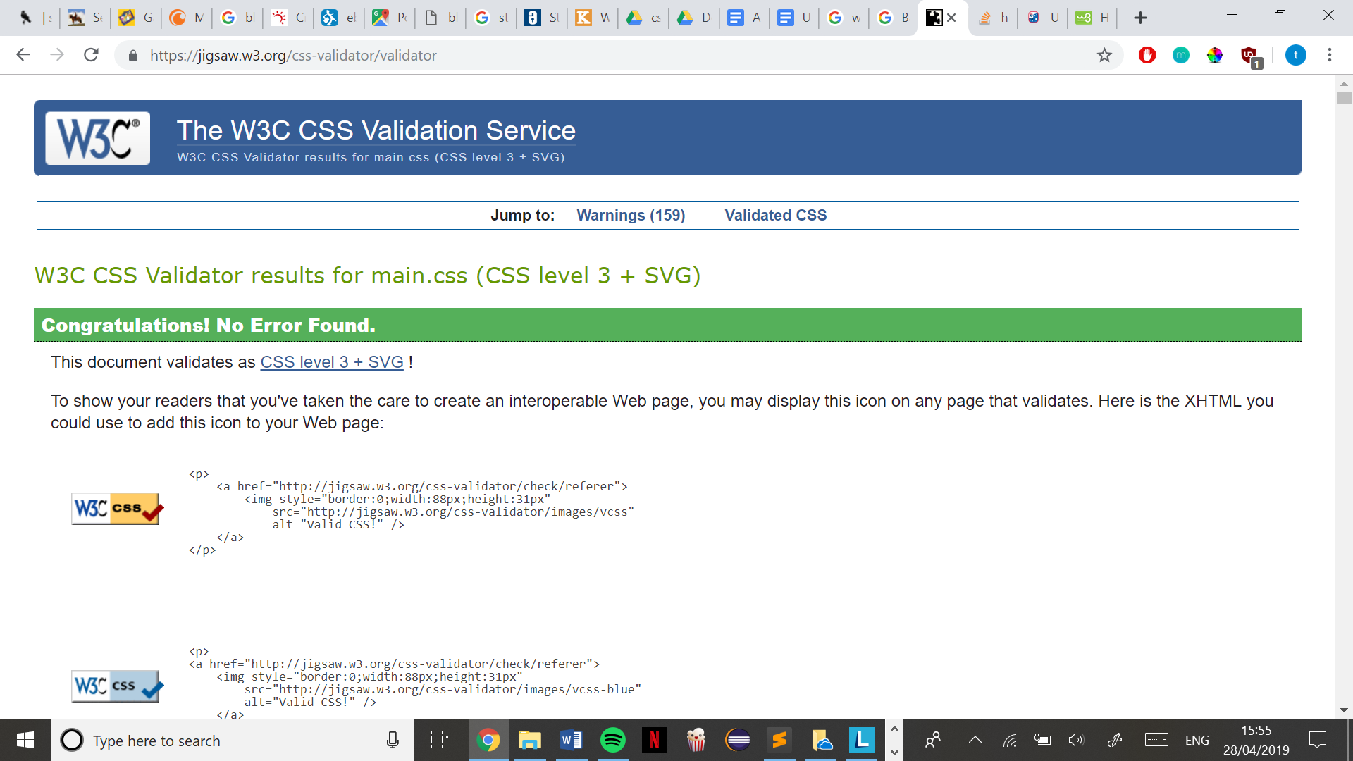

Vendor.css successfully passed, no errors found.

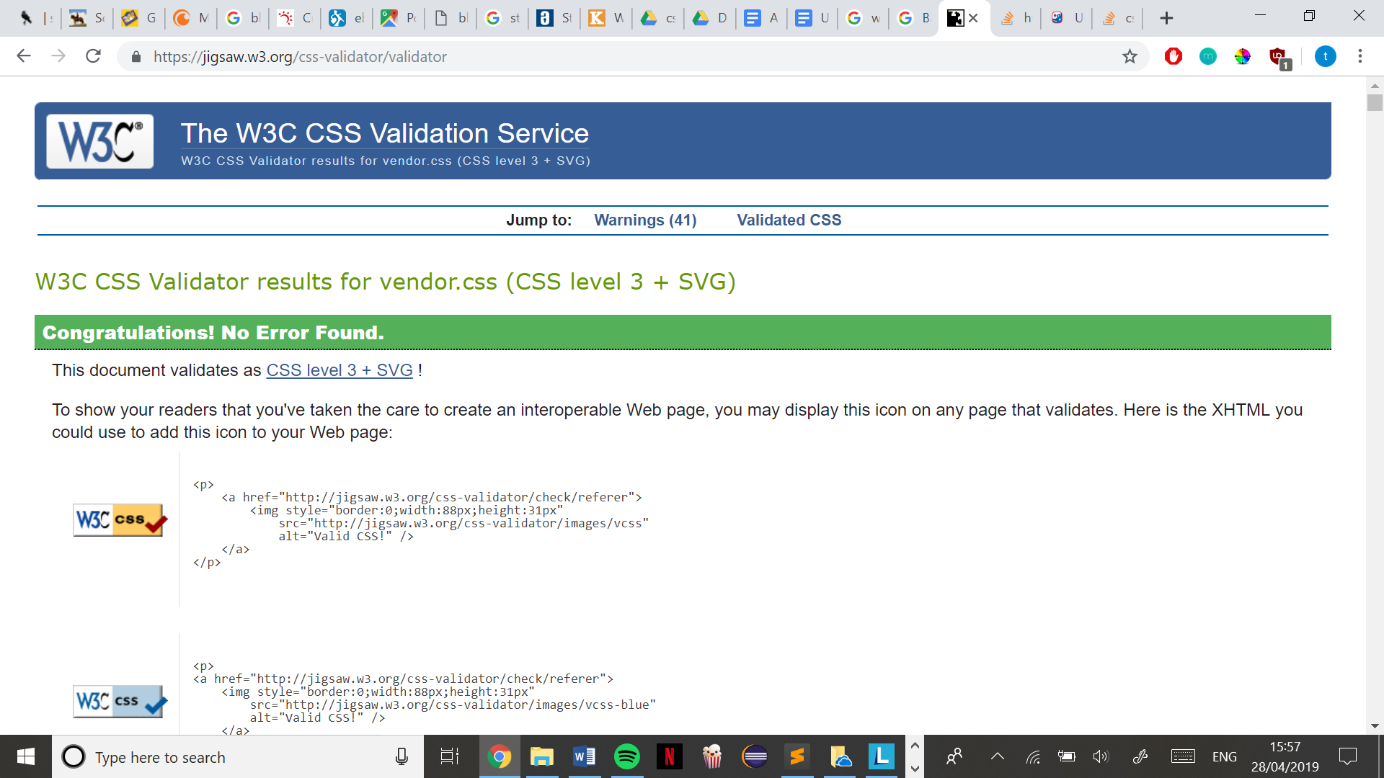

The website uses a free bootstrap layout ‘Kairos’ by StyleShout, downloaded from ThemeWagon